Subject line: Be part of the change this Childhood Dementia Day – donations doubled
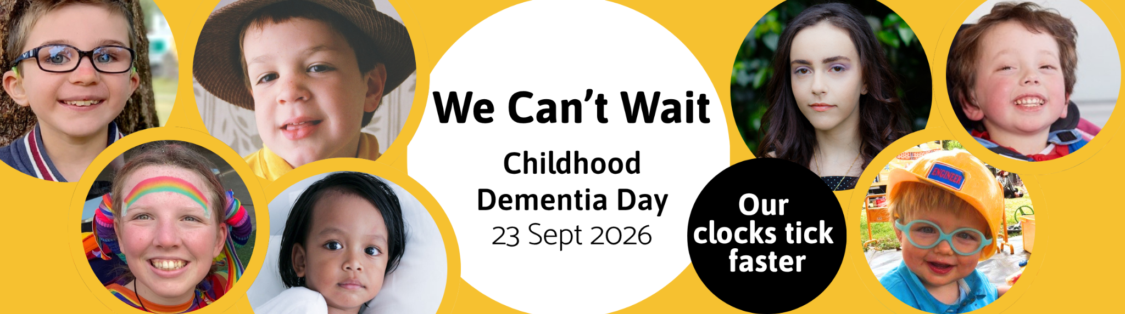

Hi [name],
I'm writing to tell you about a cause that matters to me, and a day when you can make double the difference.
Wednesday 23 September is Childhood Dementia Day.
You've probably never heard of childhood dementia, most people haven't. But in Australia, 2 babies are born every week with one of the genetic conditions that cause it. These children gradually lose skills, words and memories they've only just gained. Their families watch them fade away while the world keeps moving forward. Somewhere in the world, childhood dementia takes a life every 11 minutes.
[Optional: Add a sentence here about why this cause matters to you.]
Childhood Dementia Initiative is working to change what happens to the families impacted by childhood dementia: pushing for health, disability and care systems that understand childhood dementia, driving research and standing alongside every family while building supports around them. This Childhood Dementia Day, their message is simple: We Can't Wait.
How can you be part of the change? On Wednesday 23 September, every donation will be doubled, dollar for dollar, up to $150,000 thanks to the Hooper Shaw Foundation. One day, twice the impact.
Three things you can do:
- Donate on Wednesday 23 September at www.childhooddementia.org/wecantwait — your gift will be matched up to $150,000.
- Spread the word. Forward this email to your network, and follow Childhood Dementia Initiative on social media. In the lead-up to the day you'll meet Angelina, Caleb, Eddie, Hannah, Noah, Thomas and Toby; 7 children whose stories show exactly why We Can't Wait. Sharing their stories is the easiest way to help:
  - Instagram
  - Facebook
  - LinkedIn
- Put up a poster. Download it at www.childhooddementia.org/wecantwait and share it online or in your community: a workplace noticeboard, school, local café or community centre.
Their time is short. Your impact isn't. Please show your support.
Thanks for reading,
[Your name]

